KẾ HOẠCH DẠY HỌC KHỐI 9 NĂM HỌC 2021-2022
TUẦN 3 (20/09 – 25/09)
Tiết | Nội dung
4 | Unit 1: A Visit From A Pen Pal  VI. Write  Main focus:  1. Chatting  1. Have you ever visited any other places in Viet Nam?  2. When did you go?  3. How did you get there?  => Image you are visiting your relatives or friends in another places part of Viet Nam  2. Questions  - When did you arrive?  - Who did you meet at the bus station?  - What did you do ?  - What places did you visit ?  - What kind of food did you try ?  - How do you feel now ?  - What do you think interests you most?  - When are you returning to your home ?  => What are the parts of a personal letter?  A. Heading – writer’s address and the date.  B. Opening – Dear…. ,  C. Body of a letter.  D. Closing – your friend / regards / love.  3. Write the letter using given words and phrases  Dear…….. ,  I / arrive/ Hue Station / 7am on Sunday. Uncle Hung/ take/ me home/ taxi.  I/visit/the Imperial City. I /be / amazed / magnificent monuments there. I / also go/ Dong Ba Market, / the biggest market in Hue. This /be/ the place where/ I /buy/ a lot of souvenirs. Yesterday uncle Hung and I /go/ eat /beef noodle. I /enjoy/ it /very much.  I/ leave /Hue/ Saturday. I /be/ so happy. People in Hue /be/very nice /and friendly. I / miss /them very much. The train /be/ scheduled to come to Ha Noi/ 7pm. Please pick/ me /up /at station.  I /look forward/ meet and tell/ you about the trip in Hue.  See you then.  Yours  …………  Suggested letter:  Dear…….. ,  I arrived at Hue Station at 7am on Sunday. Uncle Hung took me home by taxi.  I’ve visited the Imperial City. I was amazed by magnificent monuments there. I also went to Dong Ba Market, the biggest market in Hue. This is the place where I bought a lot of souvenirs. Yesterday uncle Hung and I went to eat beef noodle. I enjoyed it very much.  I’ll live Hue on Saturday. I am so happy. People in Hue are very nice and friendly. I will miss them very much. The train is scheduled to come to Ha Noi at 7pm. Please pick me up at station.  I am looking forward to meeting and telling you about the trip in Hue.  See you then.  Yours  4. Homework  Sts write a similar letter at home.  Prepare for U1-LFocus 1,2,3.
5 | Unit 1: A Visit From A Pen Pal  Objective: By the end of the lesson, students students will be able to know how to use Past simple with Wish.  Main focus:  LANGUAGE FOCUS  1. Work with a partner. Ask and answer questions about what each person did on the weekend.  (Sub-board)  T : What did Ba do on the weekend?  P : He went to see a movie call “Ghosts and Monsters”.  T : When did he see it ?  P : He saw it on Saturday afternoon at 2 o’clock.  The Past simple tense: S + V₂/ V-ed.  Ex: He went to the zoo yesterday.  Cues (if):  - go to the concert performed by Hanoi singers.  - go camping held by Y and Y.  - watch a soccer match Dong Thap vs. The Cong.  - go to see the play called “Much Ado about nothing”  2. Write the things they did to prepare for the party. Use the pictures and the words in the box.  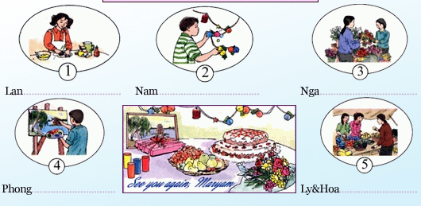  Feedback:  1. The girl made a cake.  2. The boy hung colorful lamps  3. The girl bought flowers  4. The boy painted a picture of Hanoi  5. The girl went shopping.  3. Write wishes you want to make in these situation:  The past simple with Wish :  Ex : I wish I were in the swimming pool now  I wish I had a computer now.  Form : I wish + S + past simple. (be: Were)  b- I wish I were in the swimming pool now.  c- I wish I had a computer now.  d- I wish I lived close to school.  e- I wish I had a sister.  f- I wish I drew well.  g- I wish I had my friend’s phone number.  h- I wish I knew many friends.  Homework  - Copy the answers to exercises 1,2,3 into st’s notebooks  - Prepare Unit 2 (Getting started & Listen and Read)

